## **Intelligence Fusion Center (IFC) - Product Roadmap**

**Document ID:** PRM-IFC-V1.0

**Version:** 1.0

**Date:** June 5, 2025

**Prepared By:** [Product Management Team]

**Approved By:** [Product Owner, Head of Engineering, Key Stakeholders]

### **1. Introduction**

#### **1.1 Purpose**

This Product Roadmap outlines the strategic direction and planned evolution of the Intelligence Fusion Center (IFC) System over the next 12 months. It communicates the key initiatives, their expected outcomes, and the high-level timeline for delivery, serving as a shared vision for the product team, stakeholders, and users.

#### **1.2 Vision Statement**

To empower intelligence analysts and decision-makers with a unified, intelligent platform that rapidly ingests, processes, analyzes, and predicts insights from diverse data sources, enabling proactive and informed operational decisions.

#### **1.3 Strategic Pillars**

1. **Comprehensive Data Integration:** Ensure seamless ingestion and unification of all relevant intelligence data formats.
2. **Actionable Intelligence Generation:** Leverage advanced analytics and AI to transform raw data into actionable insights.
3. **Operational Efficiency:** Automate routine tasks and streamline intelligence workflows.
4. **User Empowerment:** Provide intuitive tools and personalized experiences for diverse user roles.
5. **Predictive Capability:** Evolve from reactive analysis to proactive foresight.

### **2. Roadmap Overview**

This roadmap is a living document and may be adjusted based on new insights, market changes, or evolving organizational priorities. It focuses on **what** we are building and **why**, rather than precise dates or detailed task lists.

**Timeframe:** Q1 2026 - Q4 2026 (Fiscal Year)

| **Theme** | **Key Initiatives** | **Success Criteria (KPIs)** | **Timeframe** | **Owner(s)** |
| --- | --- | --- | --- | --- |
| **Theme 1: Core Data Foundation & Ingestion** | Establish robust and diverse data intake and storage. |  |  | **Product Lead: [PM Name] Eng Lead: [Eng Lead Name]** |
|  | **Enhance Structured Data Ingestion** | - 99.5% success rate for Excel/Access/SQL ingestion pipelines. - 20% reduction in manual data entry for structured sources. | Q1 2026 | Engineering, QA |
|  | **Expand Unstructured & IMINT Intake** | - Support 3 new digital document formats. - 95% IMINT ingestion success rate from IFC Workstations. - 10% increase in indexed unstructured data volume. | Q1 2026 | Engineering, QA |
|  | **Optimize Data Collation & Unification** | - 98% accuracy in automated data co-relation across identified common fields. - 50% reduction in time spent on manual data reconciliation. | Q2 2026 | Engineering, Data Science |
| **Theme 2: Intelligent Data Processing & Enrichment** | Transform raw data into structured, analyzable information. |  |  | **Product Lead: [PM Name] Eng Lead: [Eng Lead Name]** |
|  | **Improve Multilingual OCR Accuracy** | - Achieve >95% OCR accuracy for English, Hindi, and Mandarin on clear scanned documents. - 25% reduction in OCR review/correction time. | Q2 2026 | Data Science, QA |
|  | **Advance Text Analytics for Entity & Classification** | - 85% precision/recall for key entity extraction (persons, locations, units). - 90% accuracy for automated document classification across defined categories. - 20% increase in analyst efficiency for initial document triage. | Q3 2026 | Data Science, Engineering |
|  | **Streamline Dictionary Management** | - 100% of new abbreviation/Orbat/location entries successfully imported/added to dictionaries. - 50% faster dictionary update process. | Q3 2026 | Engineering, QA |
| **Theme 3: Powerful Search & Retrieval** | Enable users to find information quickly and intuitively. |  |  | **Product Lead: [PM Name] Eng Lead: [Eng Lead Name]** |
|  | **Optimize Core Search Performance** | - Sub-3 second response time for 90% of basic and advanced queries. - 99.9% search index availability. | Q1 2026 | Engineering, QA |
|  | **Enhance Natural Language Search (LLM)** | - 80% relevance score for LLM-generated natural language search results. - 15% increase in user satisfaction with search capabilities (via surveys). | Q2 2026 | Data Science, Engineering |
| **Theme 4: Advanced Analytical Insights & Visualization** | Provide multi-dimensional views and deep insights from collated data. |  |  | **Product Lead: [PM Name] Eng Lead: [Eng Lead Name]** |
|  | **Refine Geospatial Analysis & Geo-Fencing** | - Sub-2 second map rendering for typical data volumes. - 95% accuracy for geo-fencing data filtering. - 100% custom element export success rate. | Q3 2026 | Engineering, QA |
|  | **Improve Temporal Analysis & Event Comparison** | - Sub-1 second timeline rendering for typical event sets. - 90% user satisfaction with event comparison features. | Q3 2026 | Engineering, QA |
|  | **Deepen Graph Analysis & Relationship Discovery** | - Sub-2 second graph rendering for typical node/edge counts. - 20% increase in identified hidden relationships (via analyst feedback). | Q4 2026 | Engineering, Data Science |
| **Theme 5: Workflow Automation & Reporting** | Streamline operational processes and deliver actionable intelligence outputs. |  |  | **Product Lead: [PM Name] Eng Lead: [Eng Lead Name]** |
|  | **Automate Key Intelligence Workflows** | - 3 critical manual intelligence processes fully automated via workflows. - 25% reduction in manual effort for data processing tasks. - 99% workflow execution success rate. | Q2 2026 | Engineering, Operations |
|  | **Standardize & Expand Report Generation** | - 100% adherence to Appendix C/JSSD formats for generated reports. - Support for 2 new custom report templates. - 99% report generation success rate across all formats. | Q3 2026 | Engineering, QA |
|  | **Enhance Report Management & Distribution** | - 95% user satisfaction with report management interface. - Implement automated report distribution to 2 new channels. | Q4 2026 | Engineering |
| **Theme 6: Predictive Intelligence & User Personalization** | Offer forward-looking capabilities and tailored user experiences. |  |  | **Product Lead: [PM Name] Eng Lead: [Eng Lead Name]** |
|  | **Develop Core Predictive Models** | - Achieve >35% accuracy for "Infiltration Hotspot Prediction" at SSCT. - Deliver initial "Unit Movement Forecast" capability. - 80% user confidence in predictive outputs (via feedback). | Q4 2026 | Data Science, Engineering |
|  | **Enable Dashboard Personalization** | - 75% of active users customize their dashboards with at least 3 widgets. - 99% success rate for adding/removing/resizing widgets. | Q4 2026 | Engineering, UX |

### **3. Visual Representations**

#### 3.1 Giant Chart

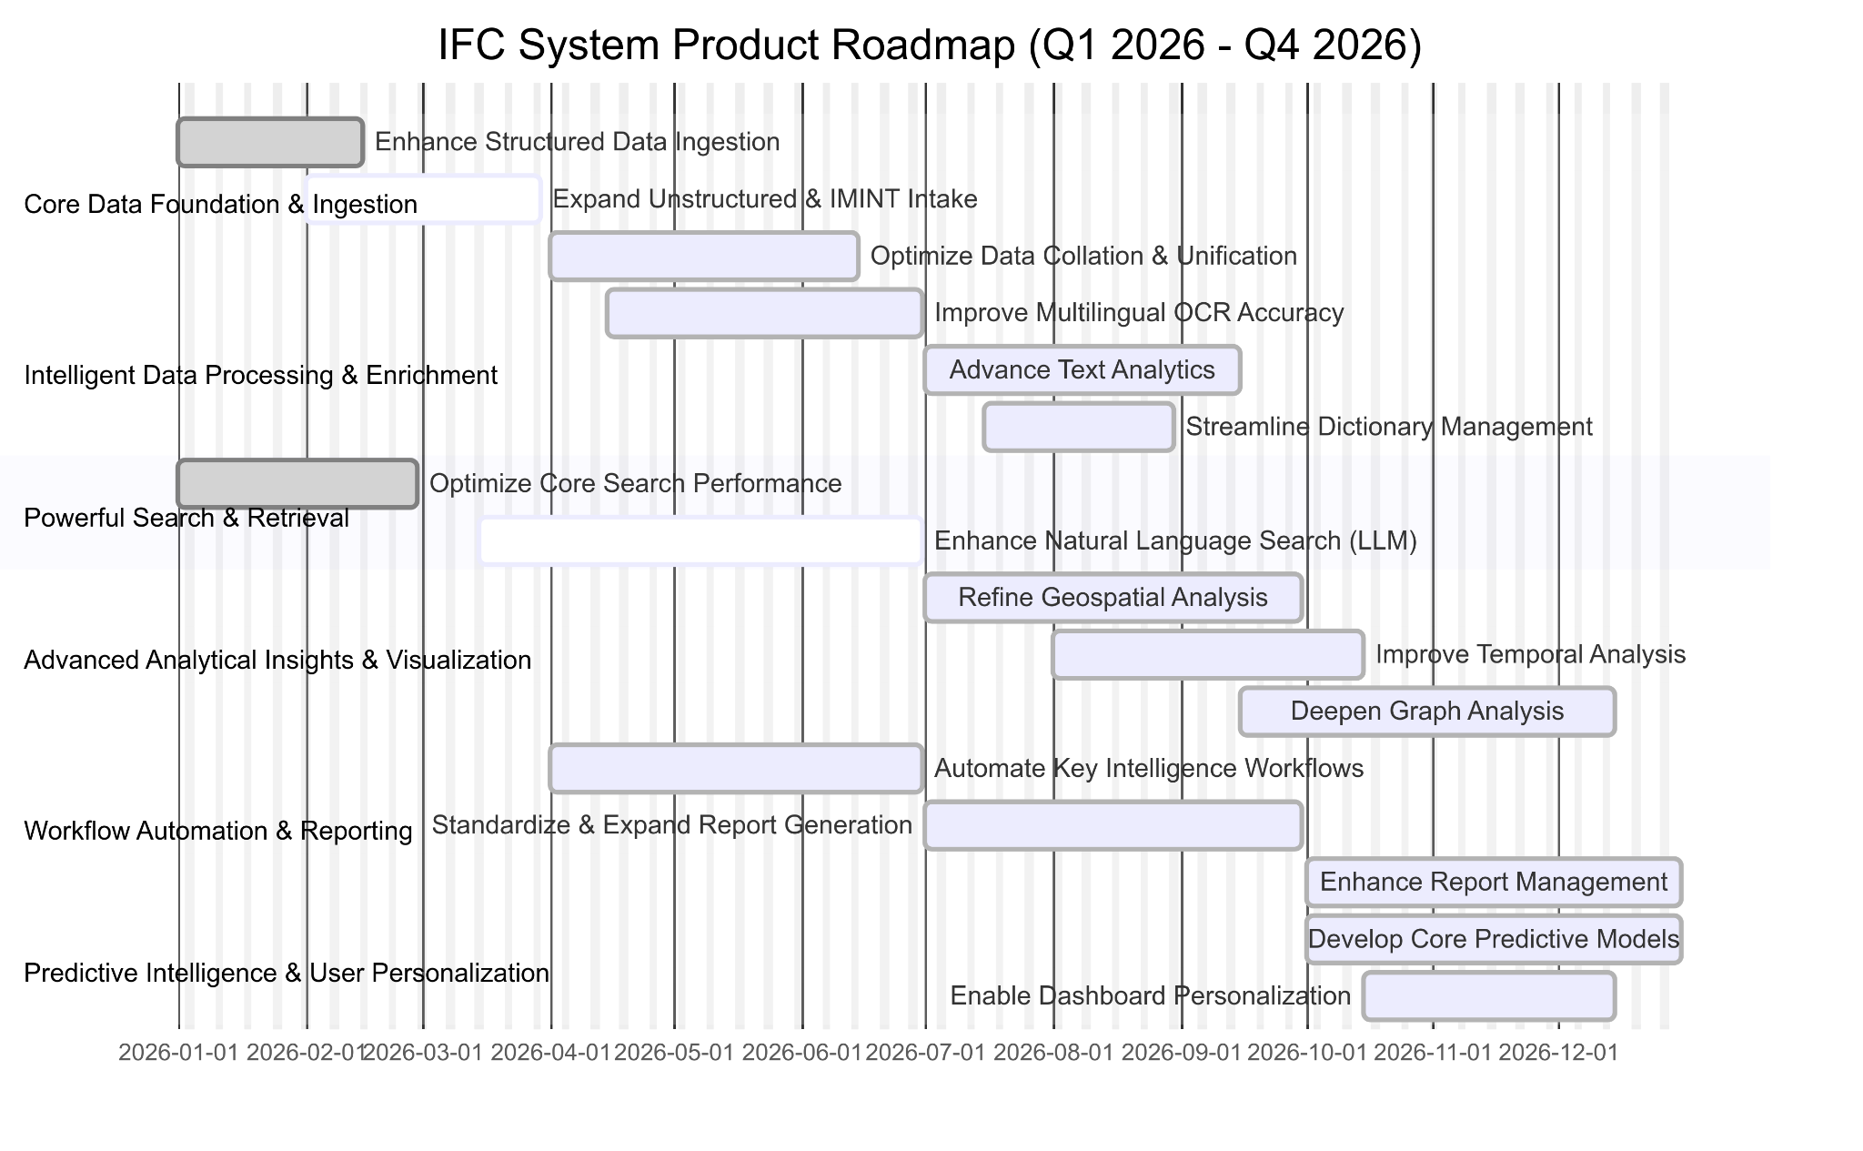

#### 3.2 Project Board

### 

### **4. Future Considerations (Beyond 12 Months)**

* Integration with real-time streaming data sources.
* Advanced AI/ML for anomaly detection and pattern recognition.
* Mobile application development for critical functionalities.
* Enhanced collaboration features for intelligence sharing.
* Integration with external decision-support systems.

### **5. Key Stakeholders**

* **Product Owner:** [Name]
* **Head of Engineering:** [Name]
* **QA Lead:** [Name]
* **Data Science Lead:** [Name]
* **End-User Representatives:** [Names/Roles]